**RAILWAY RESERVATION SYSTEM UML DIAGRAMS**

**S . JAHNAVI**

**(192011242)**

**1.USE CASE DIAGRAM**

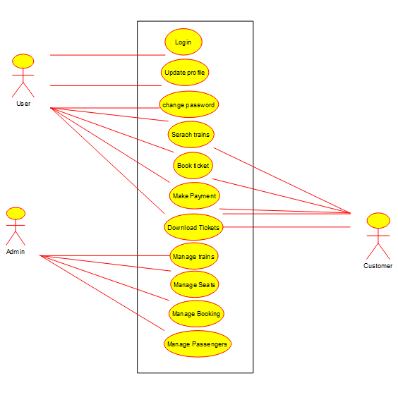

**2.SEQUENCE DIAGRAM**

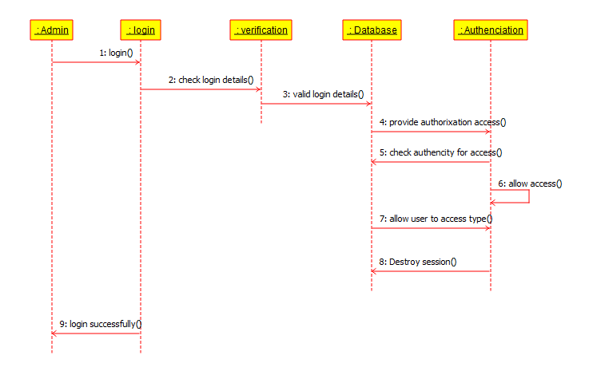

**3.CLASS DIAGRAM**

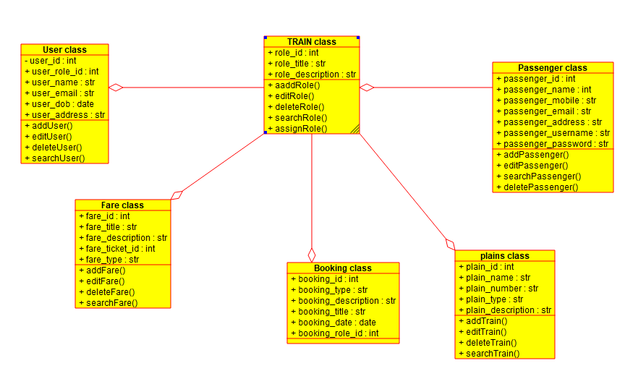

**4.STATE DIAGRAM**

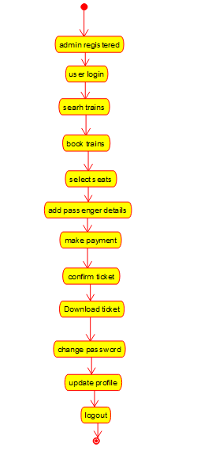

**5.ACTIVITY DIAGRAM**

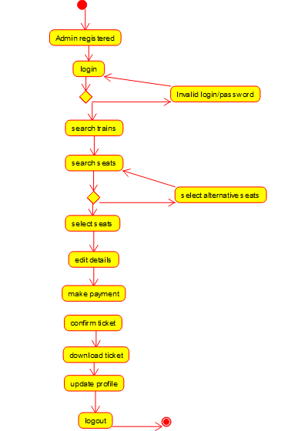

**6.COMPONENT DIAGRAM**

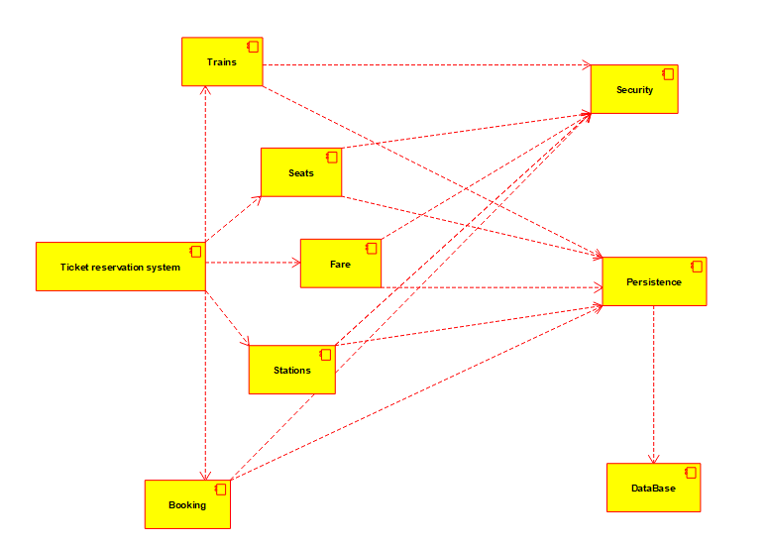

**7.DEPLOYMENT DIAGEAM**

